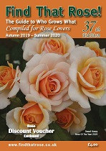
Find That Rose Order Form
please print out this order form
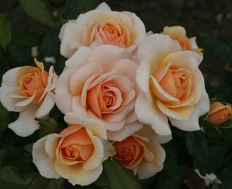
Name _____________________________________________________
Address ___________________________________________________
__________________________________________________________
__________________________________________________________
Postcode __________________________________________________
Please supply ____ copies of 37th Edition of Find That Rose at £4.70 each
Please supply ____ copies of 37th Edition of Find That Rose at £4.70 each to
Friend listed below (I have included my name as the sender)
Please arrange for a PDF at £2.90 to be sent my email address which is:
__________________________________________________________
Please supply ____copies of "What's In A Name" booklet at £2.50 each
I enclose a cheque for £____________ (made out to Find That Rose)
Friends Name _____________________________________________
Address __________________________________________________
Postcode _________________________________________________
Senders name _____________________________________________
Please send this order form with remittance to:
Editor
Find That Rose
303 Mile End Road
Colchester
Essex
CO4 5EA

